Links of Interest
👉First: Check the structure of the website here | Information Architecture

Version of the Document
Version | Date | Owner
1.0 | 14/05/2026 | Carolina Z. Aponte & Ana Gabriel Zuniga
1.1 | 1/06/2026 | Carolina Z. Aponte

Document Index
Links of Interest
Version of the Document
Document Index
1. HOMEPAGE
1.1 Hero
1.2 Your support makes a direct impact
1.3 Real Results, Tangible Change: Corcovado Foundation’s Impact
1.4 News
1.5 Allies & Sponsors
1.6 CTA to donate or contact us + Footer
2. ABOUT US
2.1 Rooted in territory. Built for long-term conservation.
2.2 Corcovado Foundation: Built from decades of field experience
2.3 Your Support Makes a Direct Impact
2.4 CTA to donate or contact us + Footer
3. OUR PROGRAMS
3.1 Programs
3.1.1 Environmental Education
3.1.2 Ecosystem Restoration
3.1.3 Sea turtle Conservation
3.1.4 National Park Support
3.2 CTA to donate or contact us + Footer
4. HOW TO GET INVOLVED
4.1 Live your Dream of Conservation
4.2 How do you want to experience Corcovado?
4.3 Testimonials from Volunteers
4.4.1 Testimonial one
4.4 CTA to donate or contact us + Footer
5. CONTACT US
6. DONATE NOW

1. HOMEPAGE

1.1 Hero
Title: Do you want to be a guardian of one of the most biodiverse places on Earth?
Descriptor text: Corcovado Foundation is the only organization working in the Corcovado National Park
Button 1: Become a volunteer / Button 2: Donate now
Remove the tags that confuse the user with secondary look&feel buttons: “Community-led conservation Measurable impact across land and sea Education that transforms future generations”

1.2 Your support makes a direct impact

- Environmental Education
- Ecosystem Restoration
- Sea turtle Conservation
- National Park Support
Objective of this is to get to know the different programs in which people can be a guardian/volunteer

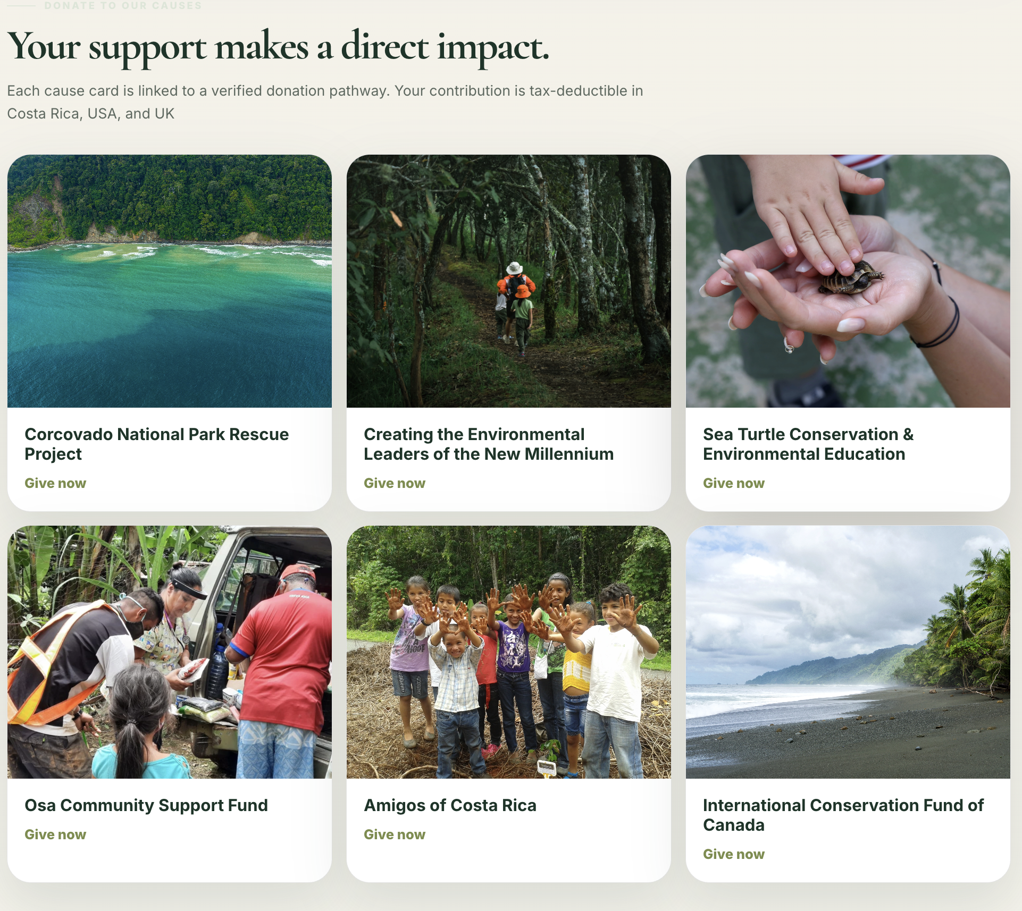

1.3 Real Results, Tangible Change: Corcovado Foundation’s Impact
Be part of the impact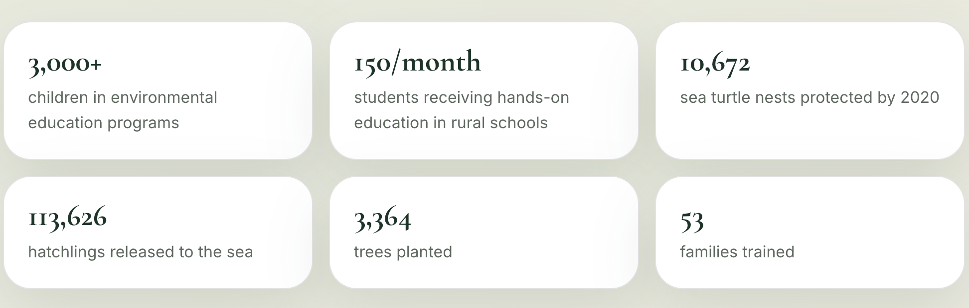
Objective of this to get to know the impact this organization does

1.4 News
Place here the top 3 latest news by cards.

1.5 Allies & Sponsors
Logos should be here placed [for instance rotating in loop]

1.6 CTA to donate or contact us + Footer
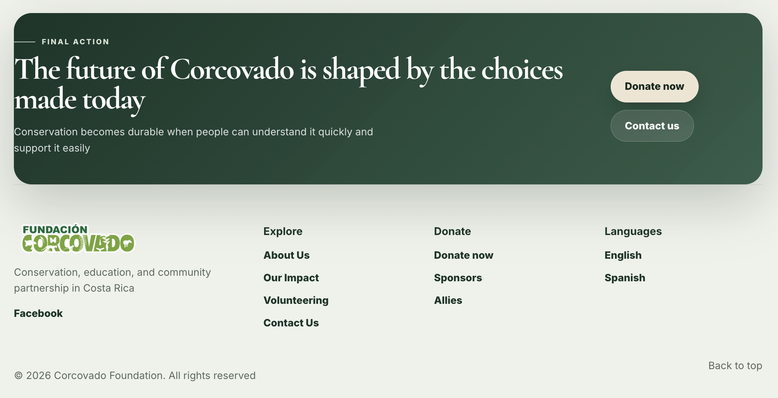
Donate now button should take the user here
Contact us button should take the user here
Social media icons to make it more visual. Working as buttons. Selecting the button will open a new tab on the browser.

2. ABOUT US

2.1 Rooted in territory. Built for long-term conservation.
Recommendation to make this look less as a hero section in the landing page of this website.

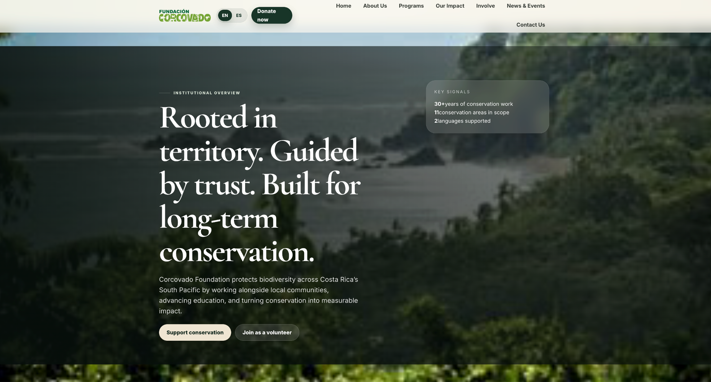

2.2 Corcovado Foundation: Built from decades of field experience
Mix content to make this a whole section, do not split them
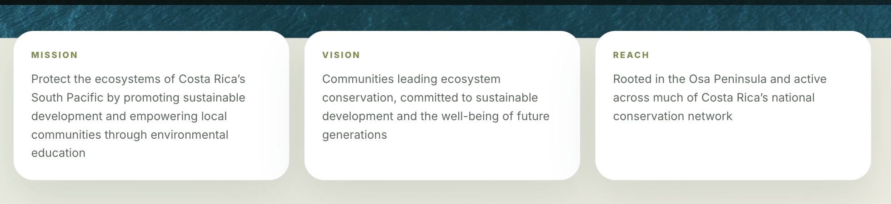
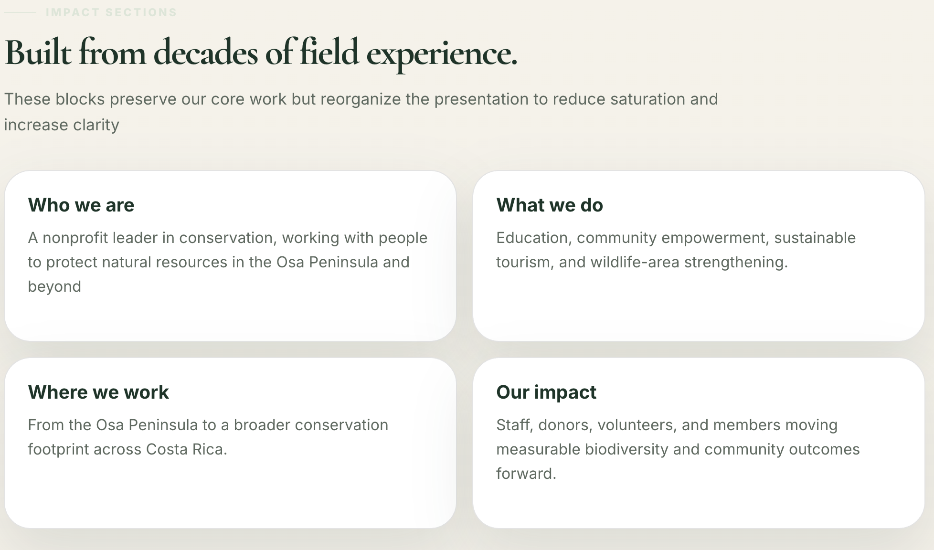
Nombres específicos.
“Our Team”

2.3 Your Support Makes a Direct Impact
- Environmental Education
- Ecosystem Restoration
- Sea turtle Conservation
- National Park Support
We need the content for these

2.4 CTA to donate or contact us + Footer
Donate now button should take the user here
Contact us button should take the user here
Social media icons to make it more visual. Working as buttons. Selecting the button will open a new tab on the browser.

3. OUR PROGRAMS
Once the user enters a program at the bottom it will appear some cards to access the other program detailed page.

Here an example:
- Program page list example 1
- Program page example 1 with donate now section always available
- Building life together section example for “Other Programs”
- GlobalGiving Corcovado Donations Metrics

3.1 Programs
Falta contenido de cada programa

3.1.1 Environmental Education

3.1.2 Ecosystem Restoration

3.1.3 Sea turtle Conservation

3.1.4 National Park Support

3.2 CTA to donate or contact us + Footer
Donate now button should take the user here
Contact us button should take the user here
Social media icons to make it more visual. Working as buttons. Selecting the button will open a new tab on the browser.

4. HOW TO GET INVOLVED
[Falta información para ser voluntario, donar y cuales cuentas o por cuales medios donar]

4.1 Live your Dream of Conservation
Become a vital part of the Corcovado Foundation through our immersive Biohostel volunteering programs.

The Destination – The Osa Peninsula: Nature’s Final Frontier. A place where the rainforest meets the sea, hosting 2.5% of the world’s biodiversity. Your journey into the wild starts here.

4.2 How do you want to experience Corcovado?
Card 1: Individual: Deep dive into daily conservation work and community life.
Card 2: Companies & Universities: Immersive learning environment for schools, universities and companies for team cohesion.
Card 3: Internships:

[Each card take the user to the following information]
[We need the content]

4.3 Testimonials from Volunteers

4.4.1 Testimonial one
“Getting here was a dream. Seeing the turtles reach the ocean for the first time changed how I see the world” - Name, Volunteer, Corcovado Foundation

4.4 CTA to donate or contact us + Footer
Donate now button should take the user here
Contact us button should take the user here
Social media icons to make it more visual. Working as buttons. Selecting the button will open a new tab on the browser.

5. CONTACT US
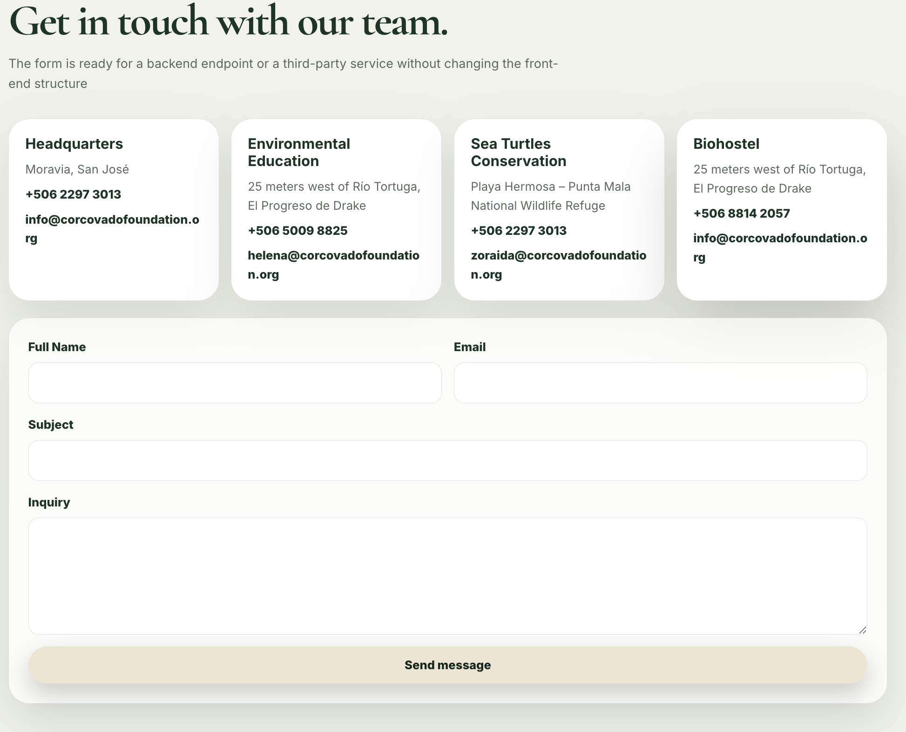
Donate now button should take the user here
Contact us button should take the user here
Social media icons to make it more visual. Working as buttons. Selecting the button will open a new tab on the browser.

6. DONATE NOW
Information on how to donate for a specific cause.
Process, etc

